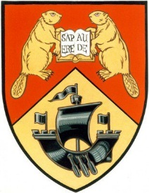

APPLICATION FOR 2018-19 GRADUATION
COMMITTEE CHAIR
Due: July 6th, 2018 at 4:00PM

The Law Students’ Society is looking for one or two 3L students to chair the Graduation Committee for the 2018-19 term. The chair(s) will be responsible for helping to fundraise for graduation, choosing the graduation gift for grads and Ludlow, organizing grad dinner and scheduling graduation photos for the 3L class.
Please send applications to Molly Murphy at lss@unb.ca.
Name: _______________________________________
Please explain any experience you have with event planning.
__________________________________________________________________________________________________________________________________________________________________________________________________________________________________________________________________________________________________________________________________________________________________________________________________________________________________________________________________________________________________________
Please list experience you have with soliciting donations and/or fundraising.
__________________________________________________________________________________________________________________________________________________________________________________________________________________________________________________________________________________________________________________________________________________________________________________________________________________________________________________________________________________________________________

Please list potential ideas for events and fundraising for Graduation Committee.
__________________________________________________________________________________________________________________________________________________________________________________________________________________________________________________________________________________________________________________________________________________________________________________________________________________________________________________________________________________________________________

